**USER INTERFACE (UI) DESIGN**

* Design language is English.
* When you run the program, a window which title is “Management System” and 3 blue buttons appear. These buttons are teacher, student and parent buttons.

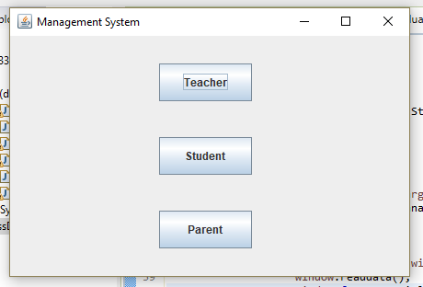

* Teacher button includes 3 grades, recommendation field and status field for each student in checkbox.

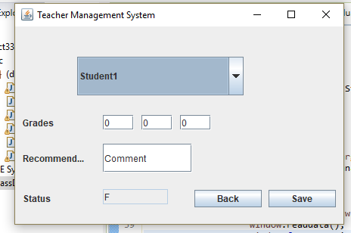

* Student button includes text areas for each student in checkbox. Students can access their information, grades and status by controlling text area.

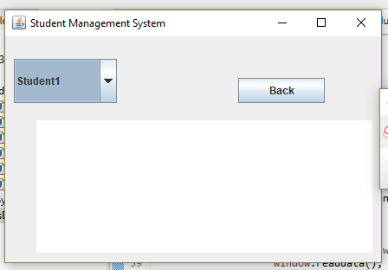

* Parent button includes a username field and password field. Each parent can access their own child information, grades, status and recommendation.

